Objectives

- Learn how switches learn the MAC addresses on the network and how this information is maintained in the MAC Address Table.
- NOTE: If you enter text in PT that is not a command you will get a “searching” message and
go into wait state. Hit CTL-SHIFT-6 to exit!
- Create a word DOC file – LAB2B-yourlastname.DOCX
- Format the headers per the SUBMISSION GUIDELINES in our iLearn resources
- Include the following sections in your lab submission
  - Purpose - In your own words, what is the purpose of this lab?
  - Questions – What are the answers to any questions asked in the lab?
  - Screenshots – Include any screenshots
  - New Terms/Commands – What new CLI commands or networking terms were introduced?
  - Comments/Reflection
- Read Book 100-105 Chapter 7
- Launch Packet Tracer on your workstation.
- Add a NOTE with your name, class id and the text “LAB2B MAC Address Table”

NOTE: Use the following Lab table to keep track of MAC Addresses
Lab Table | MAC ADDRESS | IP ADDRESS
PC0 |  | 192.168.10.1
SWITCH0 BASE |  | n/a
SWITCH0 F0/1 |  | n/a
SWITCH0 G0/1 |  | n/a
SWITCH1 BASE |  | n/a
SWITCH1 G0/1 |  | n/a
PC1 |  | 192.168.10.classid
PC2 |  | 192.168.10.3

A - Create the Topology
- Launch Packet Tracer on your workstation, and add the following devices:
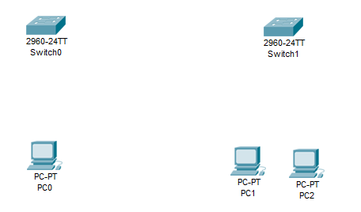
- For this exercise each of the PC's require IP addresses and we need to know their MAC (physical) addresses. For each PC:
  - Configure the correct IP address
  - Find the device MAC address (ipconfig /all)
  - Add a NOTE under each PC with the IP address and the MAC address
- At this point, your PT screens should look something like this:

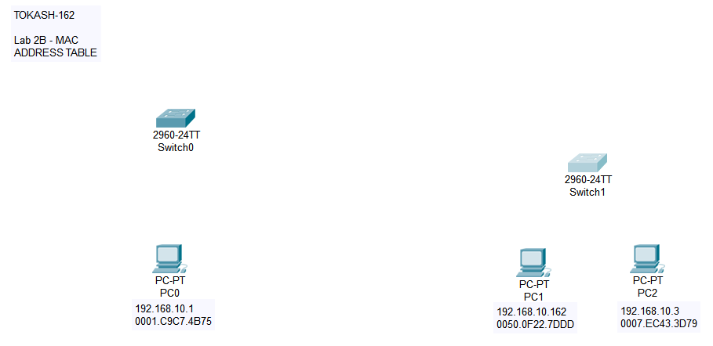

- Find and record the MAC addresses of the switches and Switch 0's ports.
  - Open the CLI window for Switch0, and enter Privileged Mode
  - Enter "show version"; find and record the switch's (base) MAC address
  - Enter "show interface fastethernet 0/1"; find and record the port's MAC address
  - Enter "show interface gigabitethernet 0/1"; find and record the port's MAC address
  - Open the CLI window for Switch1, and enter Privileged Mode
  - Enter "show version"; find and record the switch's (base) MAC address
  - Enter "show interface gigabitethernet 0/1"; find and record the port's MAC address

- Enter "show mac address-table"
Q1. What entries are initially in the Switch0 MAC address table? And why does it look like this?

- Connect PC0 to Switch0-F0/1 with a copper straight-through cable.
- On Switch0's CLI: Enter "show mac address-table"
- Has anything changed?
- Connect PC1 to Switch1
- Connect Switch0 to Switch1 using a CrossOver Cable using each switch's GigabitEthernet 0/1 port
Q2a. What is a crossover cable?
Q2b. Why do we use a crossover cable to link two switches?

- On Switch0's CLI: Enter "show mac address-table"
- Click on PC0 and open the Desktop/COMMAND PROMPT
- Enter "ping 192.168.10.UID
Q3. What entries are now in the MAC Switch0 address table? Explain why the table looks as it does.
- Connect PC2 to Switch1
- Click on PC0 and open the Desktop/COMMAND PROMPT
- Enter "ping 192.168.10.3
Q4. What entries are now in the MAC Switch0 address table? Explain why the table looks as it does.

- Enter the following global configuration command:
mac address-table static 0.0.1 vlan 1 interface fastEthernet 0/5
Q8. What entries are now in the MAC Switch0 address table? Explain why the table looks as it does.
- Include a screenshot of the final MAC Address table as well as a screen shot of your topology.

- The SHOW MAC-ADDRESS-TABLE command shows all entries in the table. Use the CLI help command for more information by typing: SHOW MAC-ADDRESS-TABLE ?
What commands can you enter to show just a subset of the table?
- Enter Simulation mode. You should see that all message types are filtered:
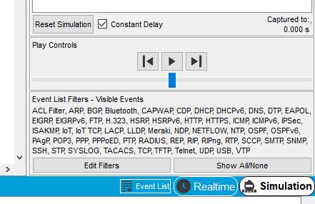
- Because we’re only interested in IMCP messages:
  - Click on SHOW ALL/NONE – this should remove ALL message types
  - Click on Edit Filters
  - Select IMCP
- Now ping or use the SIMPLE PDU icon to watch frames navigate through the network.

Note: Make a screenshot of your current Packet Tracer screen and include it your lab submission
file. Complete sections d and e. Submit in iLearn.

